**Topics: Descriptive Statistics and Probability**

1. Look at the data given below. Plot the data, find the outliers and find out $μ, σ, σ^{2}$

|  |  |
| --- | --- |
| **Name of company** | **Measure X** |
| Allied Signal | 24.23% |
| Bankers Trust | 25.53% |
| General Mills | 25.41% |
| ITT Industries | 24.14% |
| J.P.Morgan & Co. | 29.62% |
| Lehman Brothers | 28.25% |
| Marriott | 25.81% |
| MCI | 24.39% |
| Merrill Lynch | 40.26% |
| Microsoft | 32.95% |
| Morgan Stanley | 91.36% |
| Sun Microsystems | 25.99% |
| Travelers | 39.42% |
| US Airways | 26.71% |
| Warner-Lambert | 35.00% |

ANS:

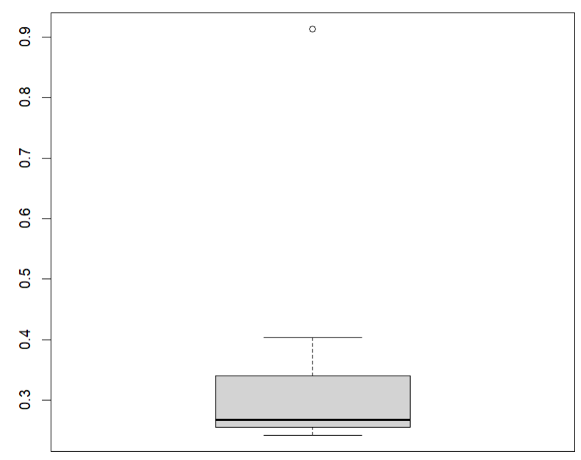

Mean = 0.333

Standard Deviation = 0.17

Variance = 0.029



Answer the following three questions based on the box-plot above.

1. What is inter-quartile range of this dataset? (please approximate the numbers) In one line, explain what this value implies.

Ans: The Inter-Quartile Range (IQR) = 12 – 5 = 7. We can observe that the 50% data lies

in Interquartile range.

1. What can we say about the skewness of this dataset?

Ans: The skewness of the distribution is Positive because the distribution is more right side of the median.

1. If it was found that the data point with the value 25 is actually 2.5, how would the new box-plot be affected?

Ans: If the data point 25 is found to be 2.5 then there will be no outliers in the distribution, thus the mean and median of the distribution subsequently changes. So we have to calculate the new mean and median.

3.



Answer the following three questions based on the histogram above.

1. Where would the mode of this dataset lie?

Ans: The mode of the data could be vary from 4 to 8. Because we can observe more frequency in that range.

1. Comment on the skewness of the dataset.

Ans: The skewness is positive because, the tail of the data is more on the right side of the peak.

1. Suppose that the above histogram and the box-plot in question 2 are plotted for the same dataset. Explain how these graphs complement each other in providing information about any dataset.

Ans: We can say that these are complement to each other because the outlier point is 25 and the graphs are positively skewed.

1. AT&T was running commercials in 1990 aimed at luring back customers who had switched to one of the other long-distance phone service providers. One such commercial shows a businessman trying to reach Phoenix and mistakenly getting Fiji, where a half-naked native on a beach responds incomprehensibly in Polynesian. When asked about this advertisement, AT&T admitted that the portrayed incident did not actually take place but added that this was an enactment of something that “could happen.” Suppose that one in 200 long-distance telephone calls is misdirected. What is the probability that at least one in five attempted telephone calls reaches the wrong number? (Assume independence of attempts.)

Ans: Probability of one call misdirected in 200 = 1/200

Probability of no errors in five calls = (1 - 1/200)^5 = 0.9752

Probability of at least one error = 1 – 0.9752 = 0.0248 = 2%

1. Returns on a certain business venture, to the nearest $1,000, are known to follow the following probability distribution

|  |  |
| --- | --- |
| x | P(x) |
| -2,000 | 0.1 |
| -1,000 | 0.1 |
| 0 | 0.2 |
| 1000 | 0.2 |
| 2000 | 0.3 |
| 3000 | 0.1 |

1. What is the most likely monetary outcome of the business venture?

Ans: $2000 has the highest probability of occurrence

1. Is the venture likely to be successful? Explain

Ans: The sum of unique probability = 0.3+0.2+0.1 = 0.6 = 60%

So the venture is likely to be 60% successful

1. What is the long-term average earning of business ventures of this kind? Explain

Ans: The average long-term earning = (-2000*0.1) + (-1000*0.1) + (0*0.2) + (1000*0.2) + (2000*0.3) + (3000*0.1) = 800.

1. What is the good measure of the risk involved in a venture of this kind? Compute this measure

Ans: From the above table we can calculate the average return like

Avg return = [-2000*0.1]+[1000*0.1]+[0*0.2]+[1000*0.2]+[2000*0.3]+[3000*0.1] = $800

Standard Deviation = [((-2000-800)^2*0.1)+((-1000-800)^0.1)+((0-800)^2*0.2)+((1000-800)^2*0.2)+((2000-800)^2*0.2)+((3000-800)^2*0.1)] = $1870.83

As, higher the Standard deviation the greater will be the risk.